Hands on 1
Spring Data JPA - Quick Example
SOLUTION:
CountryNotFoundException:
package com.cognizant.ormlearn.service;

public class CountryNotFoundException extends Exception {
public CountryNotFoundException(String message) {
super(message);
}
}
CountryService:
package com.cognizant.ormlearn.service;

import java.util.List;
import java.util.Optional;
import org.springframework.beans.factory.annotation.Autowired;
import org.springframework.stereotype.Service;
import org.springframework.transaction.annotation.Transactional;
import com.cognizant.ormlearn.model.Country;
import com.cognizant.ormlearn.repository.CountryRepository;

@Service
public class CountryService {

@Autowired
private CountryRepository countryRepository;

@Transactional(readOnly = true)
public List<Country> getAllCountries() {
return countryRepository.findAll();
}

@Transactional(readOnly = true)
public Country findCountryByCode(String countryCode) throws CountryNotFoundException {
Optional<Country> result = countryRepository.findById(countryCode);
if (!result.isPresent()) {
throw new CountryNotFoundException("Country not found");
}
return result.get();
}

@Transactional
public void addCountry(Country country) {
countryRepository.save(country);
}

@Transactional
public void updateCountry(String code, String name) throws CountryNotFoundException {
Optional<Country> result = countryRepository.findById(code);
if (!result.isPresent()) {
throw new CountryNotFoundException("Country not found");
}
Country country = result.get();
country.setName(name);
countryRepository.save(country);
}

@Transactional
public void deleteCountry(String code) {
countryRepository.deleteById(code);
}
}
OrmLearnApplication:
package com.cognizant.ormlearn;

import org.slf4j.Logger;
import org.slf4j.LoggerFactory;
import org.springframework.boot.SpringApplication;
import org.springframework.boot.autoconfigure.SpringBootApplication;
import org.springframework.context.ApplicationContext;
import com.cognizant.ormlearn.model.Country;
import com.cognizant.ormlearn.service.CountryService;
import com.cognizant.ormlearn.service.CountryNotFoundException;

@SpringBootApplication
public class OrmLearnApplication {

private static final Logger LOGGER = LoggerFactory.getLogger(OrmLearnApplication.class);
private static CountryService countryService;

public static void main(String[] args) {
LOGGER.info("Inside main");

ApplicationContext context = SpringApplication.run(OrmLearnApplication.class, args);
countryService = context.getBean(CountryService.class);

testUpdateCountry();
testDeleteCountry();
}

private static void testUpdateCountry() {
LOGGER.info("Start Update Country");
try {
countryService.updateCountry("JP", "Japan Updated");
Country updatedCountry = countryService.findCountryByCode("JP");
LOGGER.debug("Successfully updated country: {}", updatedCountry);
} catch (CountryNotFoundException e) {
LOGGER.error("Update failed: {}", e.getMessage());
}
LOGGER.info("End Update Country");
}

private static void testDeleteCountry() {
LOGGER.info("Start Delete Country");
countryService.deleteCountry("JP");
try {
countryService.findCountryByCode("JP");
LOGGER.error("Country was not deleted!");
} catch (CountryNotFoundException e) {
LOGGER.debug("Success! Country deleted. Exception confirmed: {}", e.getMessage());
}
LOGGER.info("End Delete Country");
}
}
RESULT:

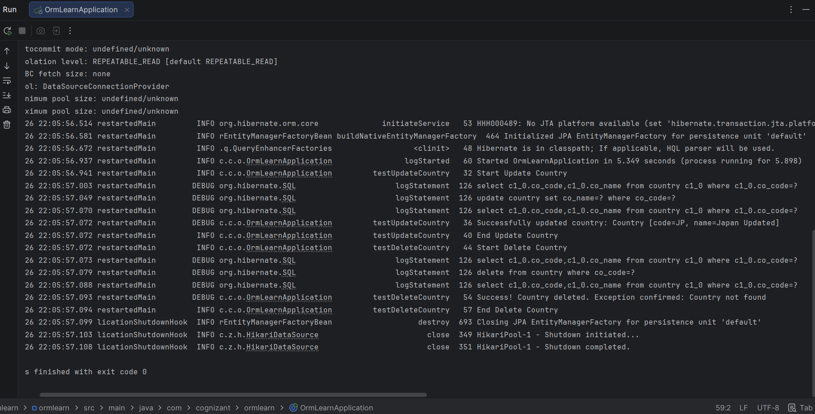
Hands on 4
Difference between JPA, Hibernate and Spring Data JPA
SOLUTION:
Employee:
package com.cognizant.ormlearn.model;

import jakarta.persistence.Column;
import jakarta.persistence.Entity;
import jakarta.persistence.GeneratedValue;
import jakarta.persistence.GenerationType;
import jakarta.persistence.Id;
import jakarta.persistence.Table;

@Entity
@Table(name = "employee")
public class Employee {

@Id
@GeneratedValue(strategy = GenerationType.IDENTITY)
@Column(name = "em_id")
private Integer id;

@Column(name = "em_name")
private String name;

// Getters and Setters
public Integer getId() { return id; }
public void setId(Integer id) { this.id = id; }
public String getName() { return name; }
public void setName(String name) { this.name = name; }
}
EmployeeRepository:
package com.cognizant.ormlearn.repository;

import org.springframework.data.jpa.repository.JpaRepository;
import org.springframework.stereotype.Repository;
import com.cognizant.ormlearn.model.Employee;

@Repository
public interface EmployeeRepository extends JpaRepository<Employee, Integer> {
}
EmployeeService:
package com.cognizant.ormlearn.service;

import org.springframework.beans.factory.annotation.Autowired;
import org.springframework.stereotype.Service;
import org.springframework.transaction.annotation.Transactional;
import com.cognizant.ormlearn.model.Employee;
import com.cognizant.ormlearn.repository.EmployeeRepository;

@Service
public class EmployeeService {

@Autowired
private EmployeeRepository employeeRepository;

@Transactional
public void addEmployee(Employee employee) {
employeeRepository.save(employee);
}
}
OrmLearnApplication:
package com.cognizant.ormlearn;

import org.slf4j.Logger;
import org.slf4j.LoggerFactory;
import org.springframework.boot.SpringApplication;
import org.springframework.boot.autoconfigure.SpringBootApplication;
import org.springframework.context.ApplicationContext;
import com.cognizant.ormlearn.model.Employee;
import com.cognizant.ormlearn.service.EmployeeService;

@SpringBootApplication
public class OrmLearnApplication {

private static final Logger LOGGER = LoggerFactory.getLogger(OrmLearnApplication.class);
private static EmployeeService employeeService;

public static void main(String[] args) {
LOGGER.info("Inside main");

ApplicationContext context = SpringApplication.run(OrmLearnApplication.class, args);
employeeService = context.getBean(EmployeeService.class);

testAddEmployee();
}

private static void testAddEmployee() {
LOGGER.info("Start Add Employee");

Employee employee = new Employee();
employee.setName("John Doe");

employeeService.addEmployee(employee);

LOGGER.info("Successfully added Employee with ID: {}", employee.getId());
LOGGER.info("End Add Employee");
}
}
RESULT:
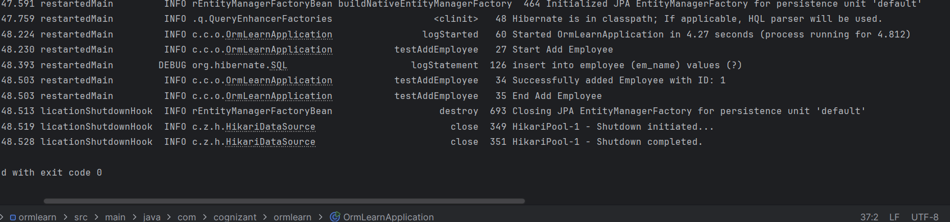
Implement services for managing Country :
SOLUTION:
CountryRepository:
package com.cognizant.ormlearn.repository;

import java.util.List;
import org.springframework.data.jpa.repository.JpaRepository;
import org.springframework.stereotype.Repository;
import com.cognizant.ormlearn.model.Country;

@Repository
public interface CountryRepository extends JpaRepository<Country, String> {
// Spring Data JPA automatically derives the SQL LIKE query from this method name
List<Country> findByNameContaining(String name);
}
CountryService:
package com.cognizant.ormlearn.service;

import java.util.List;
import java.util.Optional;
import org.springframework.beans.factory.annotation.Autowired;
import org.springframework.stereotype.Service;
import org.springframework.transaction.annotation.Transactional;
import com.cognizant.ormlearn.model.Country;
import com.cognizant.ormlearn.repository.CountryRepository;

@Service
public class CountryService {

@Autowired
private CountryRepository countryRepository;

// 1. Find a country based on country code
@Transactional(readOnly = true)
public Country findCountryByCode(String countryCode) throws CountryNotFoundException {
Optional<Country> result = countryRepository.findById(countryCode);
if (!result.isPresent()) {
throw new CountryNotFoundException("Country not found");
}
return result.get();
}

// 2. Add new country
@Transactional
public void addCountry(Country country) {
countryRepository.save(country);
}

// 3. Update country
@Transactional
public void updateCountry(String code, String name) throws CountryNotFoundException {
Optional<Country> result = countryRepository.findById(code);
if (!result.isPresent()) {
throw new CountryNotFoundException("Country not found");
}
Country country = result.get();
country.setName(name);
countryRepository.save(country);
}

// 4. Delete country
@Transactional
public void deleteCountry(String code) {
countryRepository.deleteById(code);
}

// 5. Find list of countries matching a partial country name
@Transactional(readOnly = true)
public List<Country> findCountriesByPartialName(String partialName) {
return countryRepository.findByNameContaining(partialName);
}
}
OrmLearnApplication
package com.cognizant.ormlearn;

import java.util.List;
import org.slf4j.Logger;
import org.slf4j.LoggerFactory;
import org.springframework.boot.SpringApplication;
import org.springframework.boot.autoconfigure.SpringBootApplication;
import org.springframework.context.ApplicationContext;
import com.cognizant.ormlearn.model.Country;
import com.cognizant.ormlearn.service.CountryService;
import com.cognizant.ormlearn.service.CountryNotFoundException;

@SpringBootApplication
public class OrmLearnApplication {

private static final Logger LOGGER = LoggerFactory.getLogger(OrmLearnApplication.class);
private static CountryService countryService;

public static void main(String[] args) {
LOGGER.info("Inside main");
ApplicationContext context = SpringApplication.run(OrmLearnApplication.class, args);
countryService = context.getBean(CountryService.class);

// Run all required operations
testFindCountryByCode();
testAddCountry();
testUpdateCountry();
testDeleteCountry();
testFindCountriesByPartialName();
}

private static void testFindCountryByCode() {
LOGGER.info("Start Find Country By Code");
try {
Country country = countryService.findCountryByCode("IN");
LOGGER.debug("Found Country: {}", country.getName());
} catch (CountryNotFoundException e) {
LOGGER.error(e.getMessage());
}
LOGGER.info("End Find Country By Code");
}

private static void testAddCountry() {
LOGGER.info("Start Add Country");
Country newCountry = new Country();
newCountry.setCode("ZZ");
newCountry.setName("TestCountry");
countryService.addCountry(newCountry);
LOGGER.info("Added new country successfully.");
LOGGER.info("End Add Country");
}

private static void testUpdateCountry() {
LOGGER.info("Start Update Country");
try {
countryService.updateCountry("ZZ", "TestCountry Updated");
Country updated = countryService.findCountryByCode("ZZ");
LOGGER.debug("Updated Name: {}", updated.getName());
} catch (CountryNotFoundException e) {
LOGGER.error(e.getMessage());
}
LOGGER.info("End Update Country");
}

private static void testDeleteCountry() {
LOGGER.info("Start Delete Country");
countryService.deleteCountry("ZZ");
LOGGER.info("Deleted country with code ZZ");
LOGGER.info("End Delete Country");
}

private static void testFindCountriesByPartialName() {
LOGGER.info("Start Find Countries By Partial Name");
List<Country> countries = countryService.findCountriesByPartialName("United");
for (Country c : countries) {
LOGGER.debug("Match: {} - {}", c.getCode(), c.getName());
}
LOGGER.info("End Find Countries By Partial Name");
}
}
RESULT:
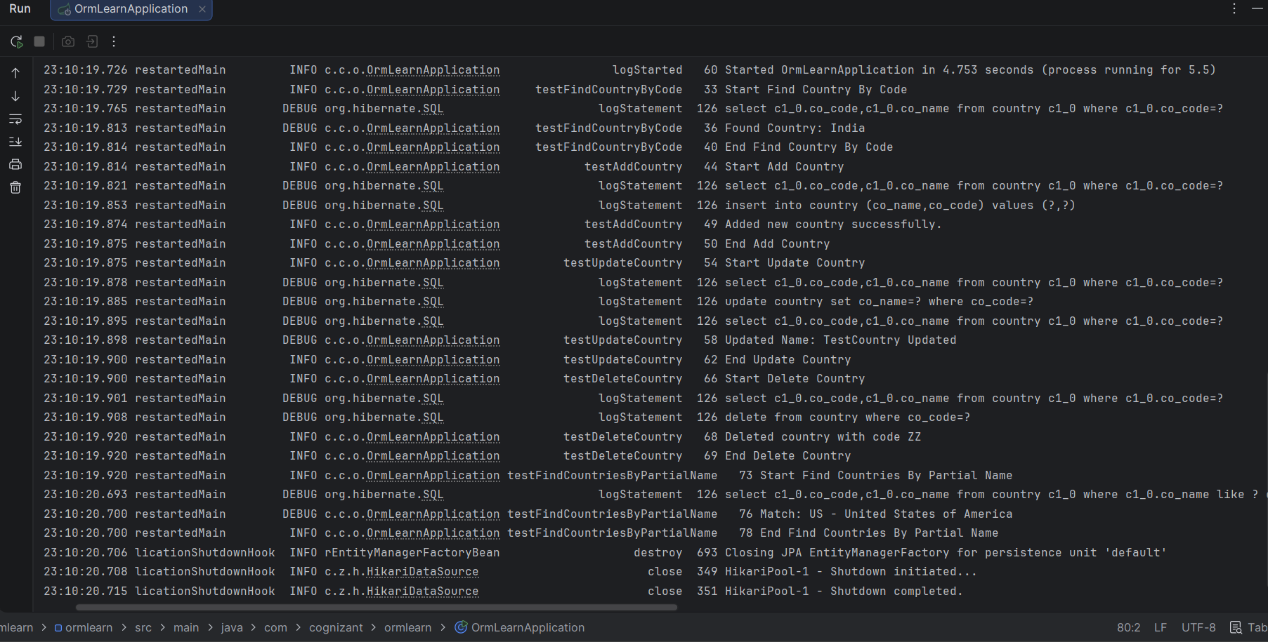
Find a country based on country code
SOLUTION:
CountryRepository:
package com.cognizant.ormlearn.repository;

import java.util.List;
import org.springframework.data.jpa.repository.JpaRepository;
import org.springframework.stereotype.Repository;
import com.cognizant.ormlearn.model.Country;

@Repository
public interface CountryRepository extends JpaRepository<Country, String> {
List<Country> findByNameContaining(String name);
}
CountryService:
package com.cognizant.ormlearn.service;

import java.util.List;
import org.springframework.beans.factory.annotation.Autowired;
import org.springframework.stereotype.Service;
import org.springframework.transaction.annotation.Transactional;
import com.cognizant.ormlearn.model.Country;
import com.cognizant.ormlearn.repository.CountryRepository;

@Service
public class CountryService {

@Autowired
private CountryRepository countryRepository;

@Transactional(readOnly = true)
public List<Country> findCountriesByPartialName(String partialName) {
return countryRepository.findByNameContaining(partialName);
}
}
OrmLearnApplication:
package com.cognizant.ormlearn;

import java.util.List;
import org.slf4j.Logger;
import org.slf4j.LoggerFactory;
import org.springframework.boot.SpringApplication;
import org.springframework.boot.autoconfigure.SpringBootApplication;
import org.springframework.context.ApplicationContext;
import com.cognizant.ormlearn.model.Country;
import com.cognizant.ormlearn.service.CountryService;

@SpringBootApplication
public class OrmLearnApplication {

private static final Logger LOGGER = LoggerFactory.getLogger(OrmLearnApplication.class);
private static CountryService countryService;

public static void main(String[] args) {
LOGGER.info("Inside main");
ApplicationContext context = SpringApplication.run(OrmLearnApplication.class, args);
countryService = context.getBean(CountryService.class);

testFindCountriesByPartialName();
}

private static void testFindCountriesByPartialName() {
LOGGER.info("Start Find Countries By Partial Name");

// Testing with 'United' as per instructions
List<Country> countries = countryService.findCountriesByPartialName("United");

for (Country c : countries) {
LOGGER.debug("Match: {} - {}", c.getCode(), c.getName());
}

LOGGER.info("End Find Countries By Partial Name");
}
}
RESULT:
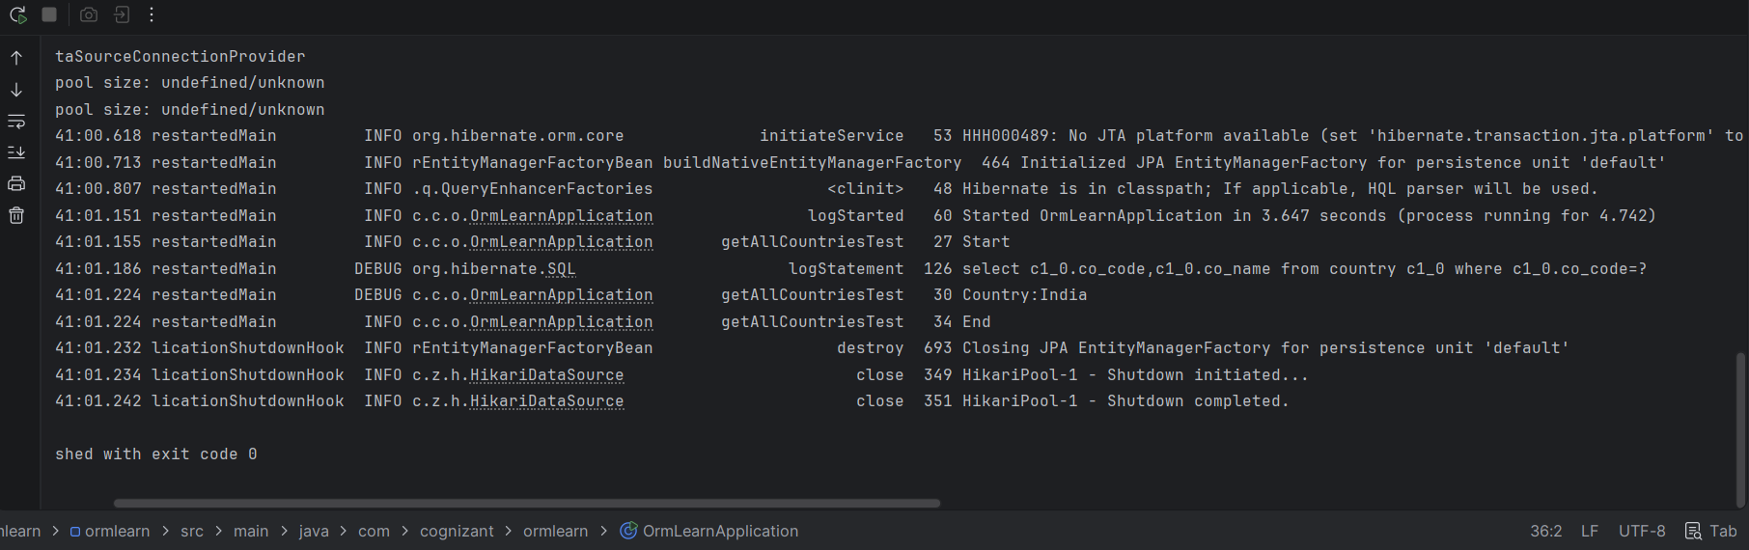
Add a new country
SOLUTION:
CountryService:
package com.cognizant.ormlearn.service;

import java.util.Optional;
import org.springframework.beans.factory.annotation.Autowired;
import org.springframework.stereotype.Service;
import org.springframework.transaction.annotation.Transactional;
import com.cognizant.ormlearn.model.Country;
import com.cognizant.ormlearn.repository.CountryRepository;

@Service
public class CountryService {

@Autowired
private CountryRepository countryRepository;

@Transactional(readOnly = true)
public Country findCountryByCode(String countryCode) throws CountryNotFoundException {
Optional<Country> result = countryRepository.findById(countryCode);
if (!result.isPresent()) {
throw new CountryNotFoundException("Country not found");
}
return result.get();
}

// New method added for this hands-on
@Transactional
public void addCountry(Country country) {
countryRepository.save(country);
}
}
OrmLearnApplication:
package com.cognizant.ormlearn;

import org.slf4j.Logger;
import org.slf4j.LoggerFactory;
import org.springframework.boot.SpringApplication;
import org.springframework.boot.autoconfigure.SpringBootApplication;
import org.springframework.context.ApplicationContext;
import com.cognizant.ormlearn.model.Country;
import com.cognizant.ormlearn.service.CountryService;
import com.cognizant.ormlearn.service.CountryNotFoundException;

@SpringBootApplication
public class OrmLearnApplication {

private static final Logger LOGGER = LoggerFactory.getLogger(OrmLearnApplication.class);
private static CountryService countryService;

public static void main(String[] args) {
LOGGER.info("Inside main");
ApplicationContext context = SpringApplication.run(OrmLearnApplication.class, args);
countryService = context.getBean(CountryService.class);

testAddCountry();
}

private static void testAddCountry() {
LOGGER.info("Start");

// 1. Create new instance of country with a new code and name
Country newCountry = new Country();
newCountry.setCode("ZZ");
newCountry.setName("TestCountry");

// 2. Call countryService.addCountry()
countryService.addCountry(newCountry);

try {
// 3. Invoke countryService.findCountryByCode() to verify
Country fetchedCountry = countryService.findCountryByCode("ZZ");
LOGGER.debug("Successfully added and verified country: {}", fetchedCountry.getName());
} catch (CountryNotFoundException e) {
LOGGER.error("Verification failed: {}", e.getMessage());
}

LOGGER.info("End");
}
}
RESULT:
